Oracle APEX

AI

Implementation

An Accenture White Paper by

Vijayan Kumar
(Vijayan.kumar@accenture.com)
Mohit Kumar Tyagi
(m.kumar.tyagi@accenture.com)
October 2024

Table of Contents
1.EDITOR’S 3
2.REVIEWED BY 3
3.OBJECTIVE 4
4.DISCLAIMER 4
5.OVERVIEW 4
6. AI-Assisted Development in APEX 5
6.1 Generative AI Service in Oracle Apex 5
6.2 Create App from a Prompt 6sssss
6.3 APEX Assistant in Code Editors 6
6.4 Open AI Assistant Dynamic Action 7
7. AI-Powered Application with APEX……………………………………………………………….8s
7.1 OCI Vision Introduction ……………………………………………………………..……….5
7.2 OCI Vision Demo: AI-Powered Image Search…………………………………………..5
7.3 OCI Vision Developer Guide:Integrating OCI Vision your APEX Apps..………...6ss
7.4 Oracle Digital Assistant: Introduction………………………………………………....6
7.5 Oracle Digital Assistant Demo:Integrating Conversational Chatbots in your Oracle APEX Apps…..7
8. OCI Generative AI: Introduction…………………………………………………………………..
8.1 OCI Generative AI Service Architecture…………………………………………………..
8.2 OCI Generative AI Demo: Building Innovative Q&A experiences in your APEX App.
8.3 OCI Generative AI Developer Guide: Integrating OCI Generative AI into your APEX Apps

8. CONCLUSION……………………………………………………………………………………………….…9
9.REFERENCES………………………………………………………………………………………………..10

1.EDITOR’S

S.No | Date | Author | Email Id | Project Role
1 | 14-Oct-2024 | Mohit Kumar Tyagi | m.kumar.tyagi@accenture.com | Team Lead

2.REVIEWED BY

Name | Author | Project/Org Role | Review Date
Vijayan Kumar | vijayan.kumar@accenture.com | Manager | 14-Oct-2024

3.OBJECTIVE
The objective of this white paper is to provide a comprehensive guide outlining the steps involved in Apex+AI implementation.

4.DISCLAIMER
This white paper is intended for informational purposes only. The implementation steps and guidelines for Oracle APEX + AI described herein are based on general best practices and are not guaranteed to address specific business or technical requirements. Oracle and the authors of this document do not assume any responsibility for errors, omissions, or results from the use of this information. All software configurations and decisions should be made in consultation with qualified professionals and aligned with your organization’s needs.

5.OVERVIEW
OCI Vision :- Integrating the OCI Vision REST API into an Oracle APEX application allows you to leverage AI capabilities for analyzing and indexing images, including those containing text uploaded by users.
Here’s a structured overview of the implementation process:
1. Prerequisites
- Oracle Cloud Account: Set up an OCI account if you don't have one.
- Oracle APEX Environment: Access to Oracle APEX for application development.
- Basic Knowledge: Familiarity with PL/SQL, RESTful APIs, and JSON.
2. Setting Up OCI Vision
- Enable OCI Vision Service: Activate the OCI Vision service in your OCI console.
- API Key Creation: Generate API keys to authenticate requests to the Vision API.
3. Building Your Oracle APEX Application
- Create or Use Existing Application
- File Upload Component
4. Configuring Web Credentials
- Go to Shared Components > Web Credentials in APEX to configure credentials for accessing the OCI Vision API.
5. Developing PL/SQL Process for API Calls
- Create a PL/SQL Process: This process will handle uploading the image to OCI Vision.
- Use UTL_HTTP: Leverage the UTL_HTTP package to make HTTP requests to the Vision API.
Example components of the PL/SQL code:
- Build the JSON request body including the image data (encoded in Base64).
- Send the request and capture the JSON response.
6. Processing the API Response
- Parse the returned JSON response to extract relevant data (e.g., recognized text, labels).
- Store results in a database for indexing or further use.
7. Displaying Results in APEX
- Create a results page to present the analysis.
- Use APEX components like reports or charts to visualize the data effectively.
8. Testing and Validation
- Conduct thorough testing with various images to ensure the integration works correctly.
- Validate that the extracted information meets user expectations.
Generative AI :- You can integrate generative AI capabilities, based on large language models (LLMs), into your applications built with Oracle APEX, your favourite low-code platform. The Generative AI service can be accessed through REST APIs, and by utilizing APEX's powerful REST Data Source capabilities, you can effortlessly incorporate this advanced technology into your applications with a low-code approach.
This process involves utilizing the generative models within the Generative AI Service to develop an "Ask Questions" feature for the New York High Schools APEX application. This functionality empowers parents to inquire about school facilities, policies, and more, helping them make informed decisions about whether a specific school is the ideal fit for their child.
How to build a conversational inquiry about schools using Generative AI wherein a user can ask questions about a school in chat and the chat widget uses Generative AI to provide context sensitive answers. This lab makes use of the latest feature of APEX 24.1 called the Open AI Assistant.
Creating a conversational inquiry system for schools using Generative AI involves leveraging the latest OpenAI Assistant feature in Oracle APEX 24.1. This allows users to ask questions about a school through a chat widget, with the AI providing context-sensitive responses. Here’s a structured overview of the implementation process:
1. Prerequisites
- Oracle APEX 24.1: Ensure you have access to this version to utilize the OpenAI Assistant feature.
- OpenAI API Key: Sign up for OpenAI and obtain an API key to integrate the Generative AI capabilities.
2. Setting Up Your Oracle APEX Application
- Create a New Application: Start a new application or use an existing one where you want to implement the chat feature.
- Design User Interface: Build a user-friendly interface that includes a chat widget for user interactions.
3. Configuring the OpenAI Assistant
- Navigate to the OpenAI Assistant settings in APEX.
- Enter your OpenAI API key and configure any settings needed for conversation context and response styles.
4. Developing the Chat Widget
- Add Chat Widget: Integrate a chat component on your APEX page.
- Handle User Inputs: Create a mechanism to capture user queries submitted through the chat interface.
5. Implementing API Calls to OpenAI
- Set Up PL/SQL Process: Create a PL/SQL process to handle API calls to the OpenAI service.
- Format Requests6. Processing the API Response
- Capture Responses: Handle the response from the OpenAI API, extracting the generated answers.
- Display Responses: Show the AI’s answers in the chat widget in a clear and user-friendly manner.
7. Contextual Enhancements
- Use Contextual Data: Enhance responses by integrating school-specific data from your database (e.g., programs offered, staff information).
- Train the Model: Optionally, fine-tune the AI’s behaviour by providing examples or specific instructions tailored to your school's context.
8. Testing and Validation
- Conduct tests with various inquiries to ensure the AI provides accurate and contextually relevant answers.
- Validate the user experience to ensure smooth interactions.

Use Cases for OCI Vision : -
Retail/E-commerce: Customers upload an image of a product, and the application searches for similar products in the inventory.
Document Management: Search for specific documents by uploading images or scanned files.
Social Media/Content Platforms: Search for similar images in a large database of visual content.
Use Cases for Generative AI : -
1. Automated Report Generation
- Description: Use generative AI to create reports based on user-selected criteria or data sets, providing insights and summaries automatically.
- Benefit: Saves time and ensures reports are tailored to user needs without manual input.
2. Smart Form Filling
- Description: Implement AI-driven autocomplete and predictive text features to assist users in filling out forms.
- Benefit: Reduces user effort and errors, improving the data entry experience.
3. Content Creation for Applications
- Description: Generate dynamic content such as articles, FAQs, or product descriptions based on user input or existing data.
- Benefit: Ensures up-to-date content and reduces the workload for content creators.
4. Intelligent Chatbots
- Description: Integrate generative AI chatbots to handle user inquiries and provide support within the application.
- Benefit: Enhances user engagement and offers 24/7 assistance, improving overall user experience.

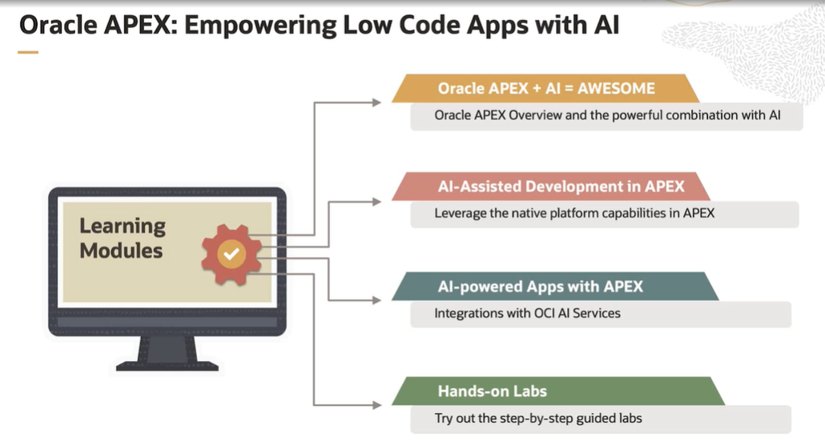

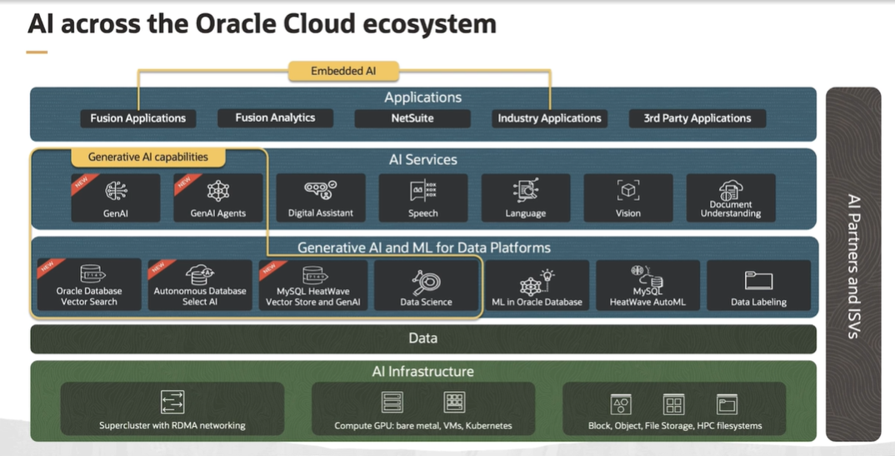

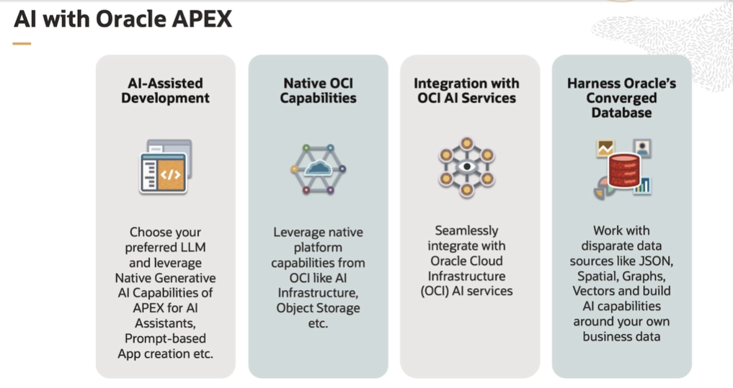

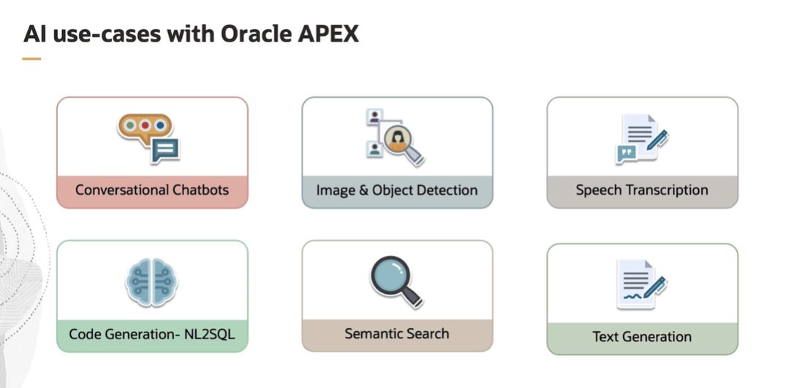

7. CONCLUSION
Integrating OCI Vision and Generative AI within Oracle APEX presents a powerful opportunity to enhance application development and user experiences. By leveraging advanced capabilities in image recognition and natural language processing, organizations can create more intelligent, responsive, and user-centric applications.
The combination of OCI Vision's robust visual analysis tools with generative AI's ability to automate content creation, enhance personalization, and provide insightful data analysis leads to significant operational efficiencies. Developers can streamline workflows, reduce manual tasks, and deliver applications that not only meet user needs but also adapt to changing requirements.
As businesses continue to seek innovative solutions to drive engagement and improve productivity, the synergy between Oracle APEX, OCI Vision, and Generative AI stands out as a strategic advantage. Organizations that embrace this integration will be well-positioned to harness the full potential of their data and deliver exceptional value to their users, ultimately driving growth and competitive differentiation in the market.

8.REFERENCES
- https://apexapps.oracle.com/pls/apex/r/dbpm/livelabs/run-workshop?p210_wid=3947
- https://oracle-livelabs.github.io/apex/ai-vision-lab/workshops/tenancy/index.html?lab=3-integrate-oci-vision

